**JavaScript Notes**

**Adding js file to html**

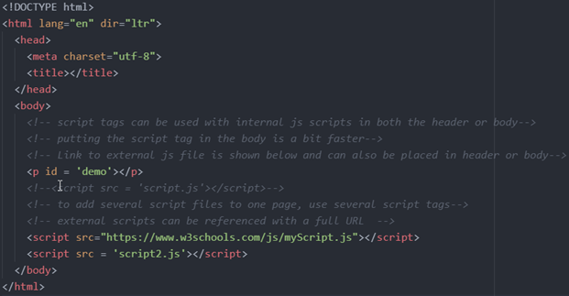

**Comments**

Single Line Comments // and Multi-Line Comments /**/

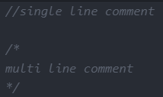

**Variables**

var

var declarations are globally scoped or function/locally scoped. If var variables are not declared a function, then it has global scope. In other words, this means any variable that is declared with var outside a function block is available for use in the whole window.

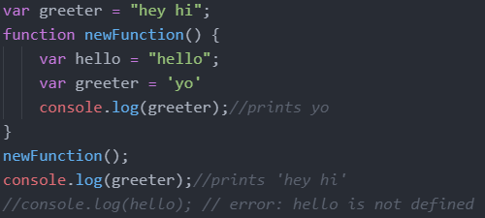

var variables can be re-declared and updated

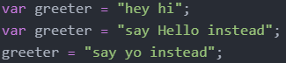

Hoisting of var. Hoisting is a JavaScript mechanism where variables and function declarations are moved to the top of their scope before code execution

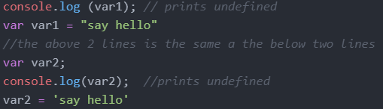

let

let is now preferred for variable declaration. let is blocked scope. a block is anything with {}When using let, you don't have to worry about if you have used a name for a variable before since a variable exists only within its scope. This fact makes let a better choice than var. Shadowing exists.

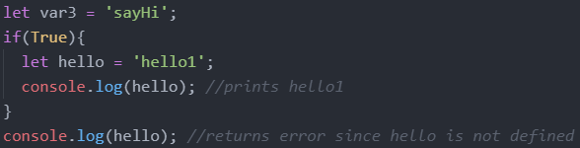

let can be updated but not re-declared

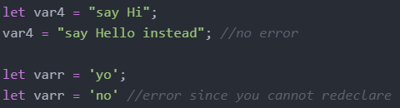

Hoisting of let. Just like var, let declarations are hoisted to the top. Unlike var which is initialized as undefined, the let keyword is not initialized. So if you try to use a let variable before declaration, you'll get a Reference Error

const

const definitions have block scope.Shadowing exists.

It does not define a constant value. It defines a constant reference to a value.



C prints out [1,2,3]

This is why we can change a const that takes on a mutable data type. The const variable takes on the memory address as its value which cannot change. But what is stored at the memory address can change.

Because of this you can NOT:

* Reassign a constant value
* Reassign a constant array
* Reassign a constant object



But you CAN:

* Change a constant array

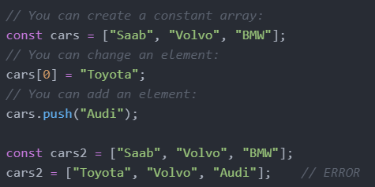

* Change a constant object

Declaring a variable with const is similar to let when it comes to Block Scope. The x declared in the block, in this example, is not the same as the x declared outside the block. Redeclaring a variable with const, in another scope, or in another block, is allowed

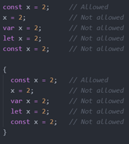

Hoisting, using a const variable before it is declared will result in a ReferenceError



**Operators**

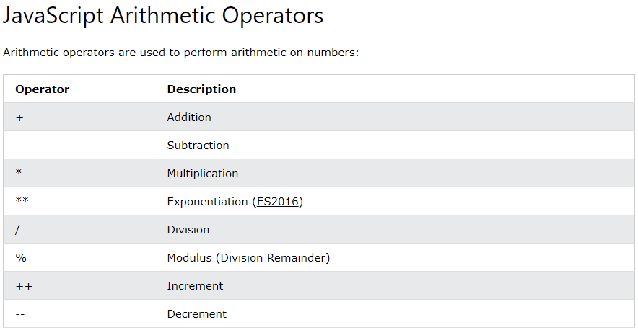

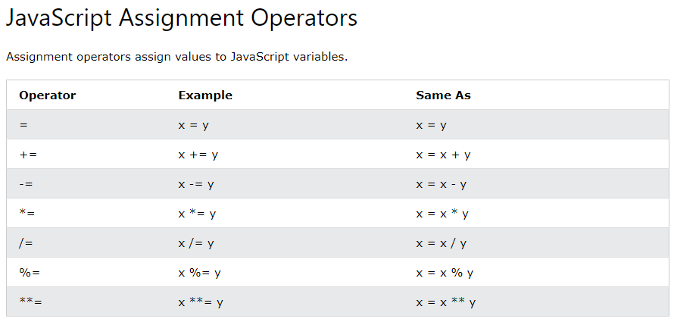

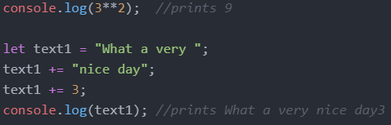

JavaScript evaluates expressions from left to right. Different sequences can produce different results:



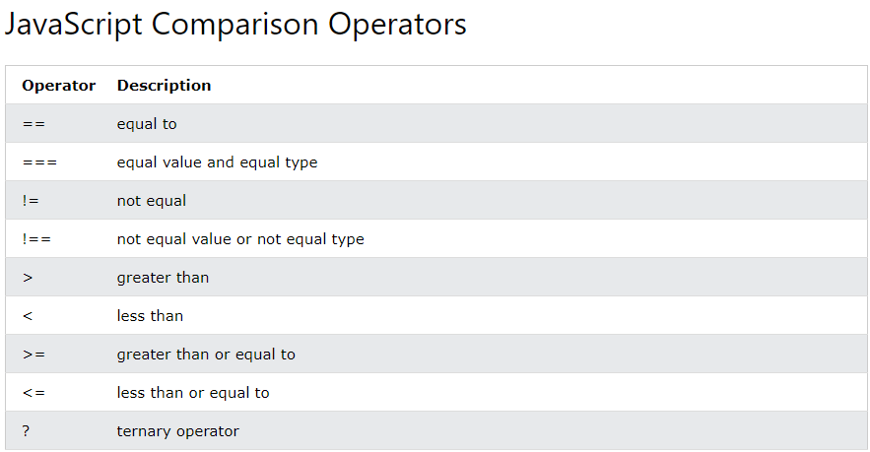

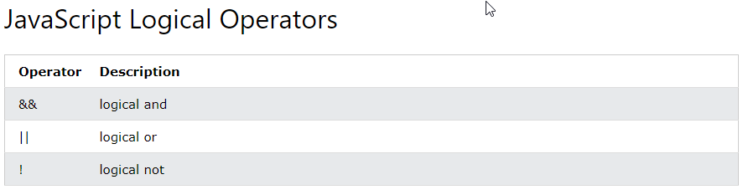

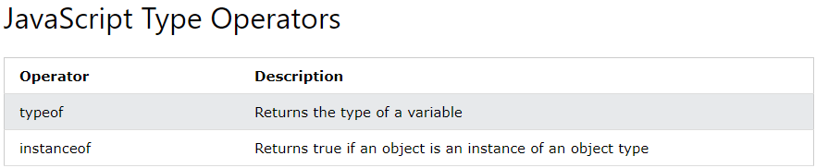

**Data Types**

Declaring Variables

Separated by semicolons, multiple statements on one line are allowed. The two codes below are the same.

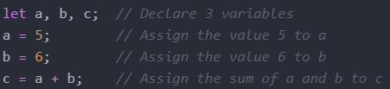



JavaScript has dynamic types. This means that the same variable can be used to hold different data types

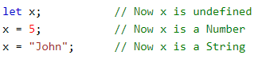

Undefined



Strings/Empty



An empty value has nothing to do with undefined. An empty string has both a legal value and a type



Numbers



The above 3 variables will print as the following 3





Booleans

let x = true;

let y = true;

Arrays



Objects

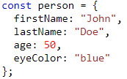

typeOf Operator



**Arrays**

Creating an Array

you can have variables of different types in the same Array such as objects, functions, arrays

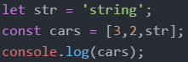



Accessing Array Elements



Changing Array Elements



Access the Full Array



This will change demo to



Adding Array Elements

The push() method add an element to the end of an the array



Adding large indexes can create holes



This will print the following

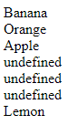

The unshift() method adds a new element to an array (at the beginning), and "unshifts" older elements:

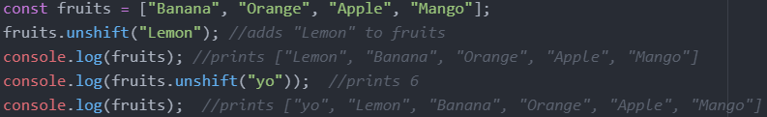

Remove Elements

The pop() method removes the last element from an array

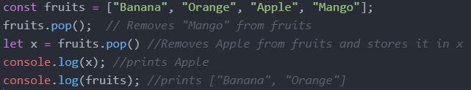

The shift() method removes the first array element and "shifts" all other elements to a lower index

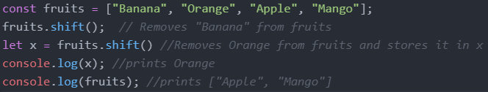

Length



typeOf and Array.isArray() and instanceof

The problem is that the JavaScript operator typeof returns "object" for arrays



To solve this issue, we can use Array.isArray or instanceof





Convert Arrays to Strings

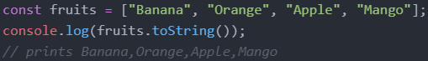

Splicing Arrays

The splice() method can be used to add new items to an array

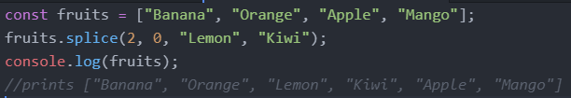

The first parameter (2) defines the position where new elements should be added (spliced in).

The second parameter (0) defines how many elements should be removed.

The rest of the parameters ("Lemon" , "Kiwi") define the new elements to be added.

Merging (Concatenating) Arrays

The concat() method creates a new array by merging (concatenating) existing arrays.

The concat() method does not change the existing arrays. It always returns a new array.

The concat() method can take any number of array arguments.

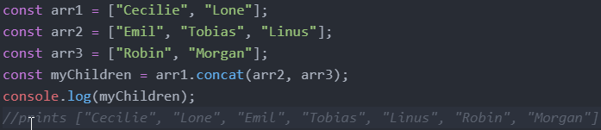

Slicing Arrays

The slice() method slices out a piece of an array into a new array.

The slice() method creates a new array. It does not remove any elements from the source array.

The slice() method can take two arguments and selects elements from the start argument, and up to (but not including) the end argument.

If the end argument is omitted, the slice() method slices out the rest of the array.

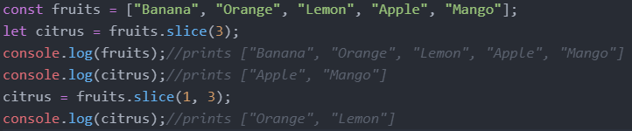

Sorting and Reversing Arrays

The sort() method sorts an array alphabetically for both strings and number elements

The reverse() method reverses the elements in an array by sorting in descending order:

Sorting Strings

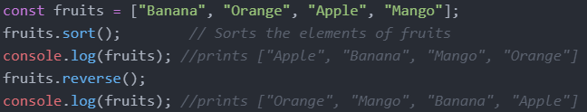

Sorting Numbers

By default, the sort() function sorts values as strings

If numbers are sorted as strings, "25" is bigger than "100", because "2" is bigger than "1".

Because of this, the sort() method will produce incorrect results when sorting numbers.

You can fix this by providing a compare function

Sort ascending: array_name.sort(function(a, b){return a - b})

Sort descending: array_name.sort(function(a, b){return b - a})

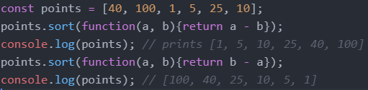

indexOf

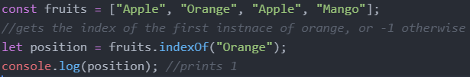

Array Iteration/ Array Methods

map()

The map() method creates a new array by performing a function on each array element.

The map() method does not execute the function for array elements without values.

The map() method does not change the original array

Syntax: array.map(function(currentValue, index, arr), thisValue)

Parameters:

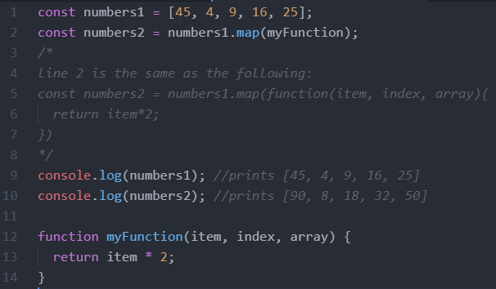

filter()

The filter() method creates a new array with array elements that passes a test. The parameter function returns true or false.

Filter does not change the original array.

Syntax: *array*.filter(function(currentValue, index, arr), thisValue)

Parameters:

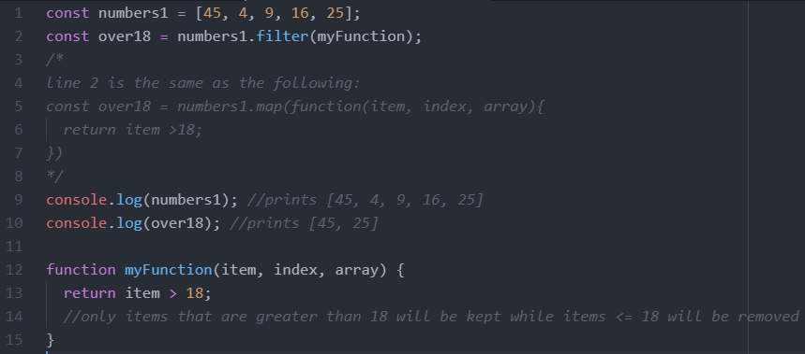

reduce()

The reduce() method runs a function on each array element to return a single value.

The reduce() method works from left-to-right in the array.

* Syntax: *array*.reduce(function(total, currentValue, currentIndex, arr), initialValue)
* Parameters:
* Graphical user interface, text, application, email

  Description automatically generated

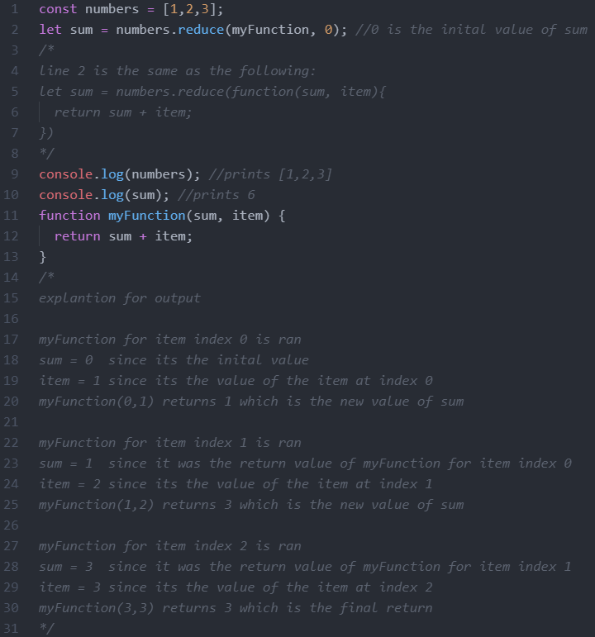

find()

The find() method returns the value of the first element that passes a test. The paramter function returns true or false.

Syntax: *array*.find(function(currentValue, index, arr),thisValue)

Parameters:

some()

* The some() method checks if any array elements pass a test (provided as a function). If at least one element passes a test, some() returns true. If all the elements fail the test, some() returns false.
* Syntax: *array*.some(function(value, index, arr), this)
* Graphical user interface, text, application

  Description automatically generated

hasInexpensiveItems will be true in the above example since there is at least one element in the items array that has a price <=100

every()

* The every() method executes a function for each array element.
* The every() method returns true if the function returns true for all elements.
* The every() method returns false if the function returns false for at least one element.
* Syntax: *array*.every(function(currentValue, index, arr), thisValue)
* Parameters:
* Graphical user interface, text, application, email

  Description automatically generated
* Text

  Description automatically generated
* The above prints false
* Text

  Description automatically generated
* The above prints true

includes()

* The includes() method returns true if an array contains a specified value.
* The includes() method returns false if the value is not found.
* Syntax: *array*.includes(element, start)
* Parameters:
* Graphical user interface, text, application

  Description automatically generated
* const fruits = ["Banana", "Orange", "Apple", "Mango"];  
  fruits.includes("Mango");
* The above returns true
* const fruits = ["Banana", "Orange", "Apple", "Mango"];  
  fruits.includes("Banana", 3);
* The above returns false since we start searching from position 3

from()

* Array.from() lets you create Arrays from: array-like objects (objects with a length property and indexed elements); or iterable objects (objects such as Map and Set)
* Array.from('foo') returns the value [“f”, “o”, “o”]
* 
* Syntax: Array.from(object, mapFunction, thisValue)
* Array.from() has an optional parameter mapFn, which allows you to execute a map() function on each element of the array being created. More clearly, Array.from(obj, mapFn, thisArg) has the same result as Array.from(obj).map(mapFn, thisArg), except that it does not create an intermediate array, and mapFn only receives two arguments (element, index).



forEach()

* forEach() method calls a function for each element in an array. (equivalent to a ‘for x in my_list’ in python)
* The forEach() method is not executed for empty elements.
* *Syntax: array*.forEach(function(currentValue, index, arr), thisValue)
* Logo

  Description automatically generated with low confidence
* A screenshot of a computer

  Description automatically generated with medium confidence

**Objects**

Object Definition

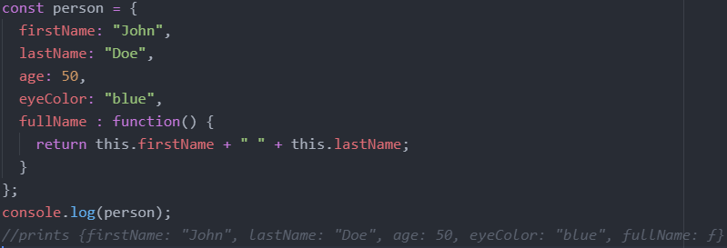

This Keyword

In a function definition, this refers to the "owner" of the function.

In the example above, this is the person object that "owns" the fullName function.

In other words, this.firstName means the firstName property of this object.

Accessing Object Properties

let name1 = objectName.propertyName

let name2 = objectName["propertyName"]

Accessing Object Methods

let fullname = objectName.methodName()

Property Shorthand

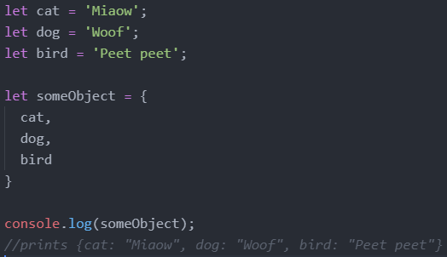

Destructuring

* The destructuring assignment syntax is a JavaScript expression that makes it possible to unpack values from arrays using square brackets, or properties from objects using curly brackets, into distinct variables.
* We take the array we want to destructor and we put it on the right side of the expression. Below we put the alphabet array on the right. Then we declare variables a inside brackets to take on the value of the first element of alphabet.
* Text, schematic

  Description automatically generated
* We can also take more than just one element from the array. The position of the elements corresponds to the position of the variable declared. Below, since a is the first item and b is the second item in [a,b], a takes on the first element in alphabet and b takes on the second element in alphabet.
* Text

  Description automatically generated
* Text

  Description automatically generated
* Suppose we only wanted a and c, then we could remove the variable declaration for b, but leave in the commas.
* Text

  Description automatically generated
* Destructuring is useful when it comes to getting return values from functions.
* Text

  Description automatically generated

Destructuring with objects

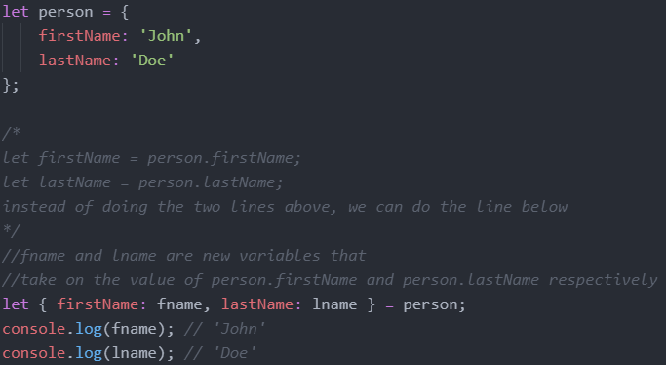

Declaring variables that have the same names as the properties of the object

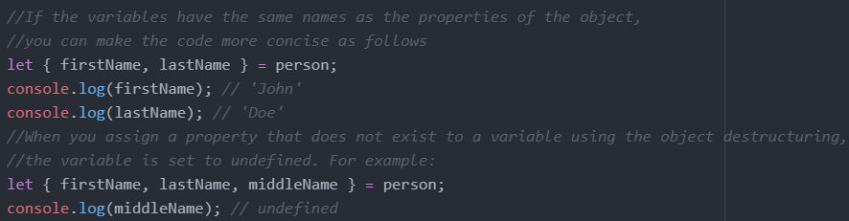

Default values

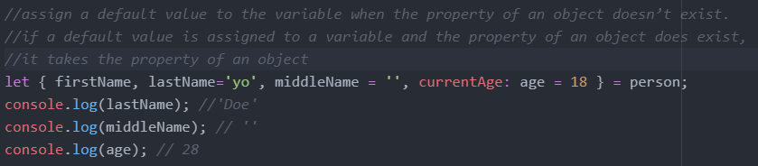

Nested object destructuring

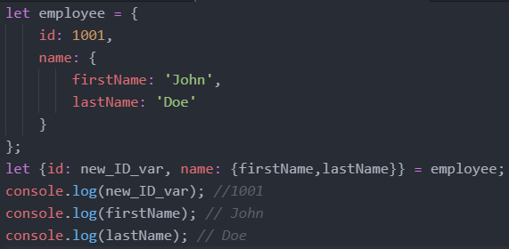

* We can also use object destructuring inside the arguments of functions
* Text, letter

  Description automatically generated
* Instead of the above, we could write the following
* Text

  Description automatically generated

Spread Operator

* We will continue from the example with the destructuring operator
* We know how to get the 1st and 3rd elements of an array without needing to get the 2nd element as shown below.
* Text

  Description automatically generated
* But what if we want to get the rest of the array elements? We can use the spread operator
* Text

  Description automatically generated
* rest is not a keyword, we get to choose the name
* we can use the spread operator to combine two arrays together as shown below
* Text

  Description automatically generated
* The above is not too useful since we could use concat() instead, but it becomes useful for objects as shown below.
* Spread with objects
* Notice below the name property is not in the variable rest since we already took it out
* Text

  Description automatically generated
* Text, letter

  Description automatically generated
* We can also destructure nested objects
* Text

  Description automatically generated
* We can also combine objects
* 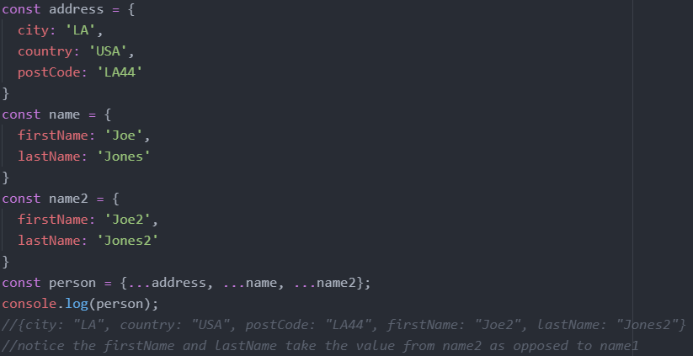

**Objects vs Arrays**

Arrays use numbered indexes while objects used name indexes

**Null vs Undefined**

* Similarities:
  + null and undefined both mean there is no value for a given thing we are trying to access
  + null == undefined // this is true
  + We can do let a = null and we can also do let a = undefined. However, let a; initializes a as undefined so the only time we would use let a = undefined is if we want to reset the variable a.
* Differences:
  + The only real difference between the two is the actual intent the programmer is trying to show.
  + It is not possible to get the keyword null in JavaScript unless some programmer specifically returns the keyword null. Thus, by using null, the programmer is explicitly saying that this thing has no value (I checked for the value, did some calculations, but there is no value). A good is example is that if we are checking if something is in a list. If it’s not in the list, we can return null.
  + Undefined is not saying that the thing has no value. It is just saying that the thing has not been defined yet. So if you do let a; and not define it, a has a value of undefined. So undefined is the default state of everything (everything is undefined until you define it).
  + Thus by using null we are saying the thing has been defined, but it has no value. By using undefined, we are saying this thing is not yet defined (it could have a value later or not have a value later, we don’t know, but as of now, the value just doesn’t exist yet).
  + null === undefined // this is false
* TLDR: null means the thing exists, it just has no value. Undefined means the thing doesn’t exist yet.

**String Methods**

Length



Escape Characters

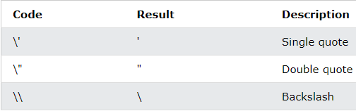

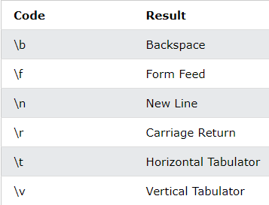

Literals Vs Objects

Normally, JavaScript strings are primitive values, created from literals, but strings can also be defined as objects with the keyword new.

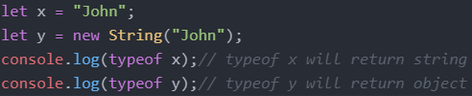

Comparing Strings and Objects/Strings

The == operator returns true if the values of two strings or objects are equal

The === operator returns true if the values and data types are equal

1 ==1 is true and 1===1 is true

1 == ‘1’ is true since the string ‘1’ is converted to an int which is 1 and they are equal. but 1 === ‘1’ is not true since an integer and string are not of the same type.

Below is a list of weird shit. You just need to know they exist, not why that’s the case.

* + 0 == ‘’ is true
  + 0 === ’’ is false
  + 0 == false is true
  + 0 === false is false
* A good use case of the === is to differentiate between null and undefined
  + null == undefined is true
  + null === undefined is false
* In general, always use === instead of == unless we are comparing null vs undefined.

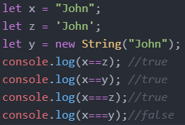

Comparing Objects and Objects

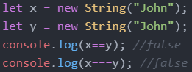

Slice()

extracts a part of a string and returns the extracted part in a new string

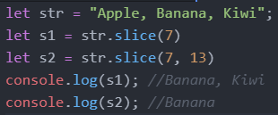

Replace()

The replace() method replaces a the first instance of a specified value with another value in a string

The replace() method is case sensitive

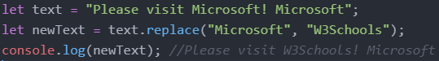

To replace case insensitive, use a regular expression with an /i flag (insensitive)

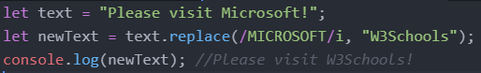

To replace all matches, use a regular expression with a /g flag (global match)

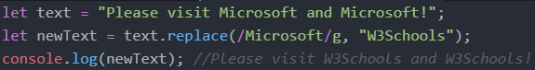

charAt()

The charAt() method returns the character at a specified index (position) in a string



indexOf()

The indexOf() method returns the index of (the position of) the first occurrence of a specified text in a string, or -1 if not found



lastIndexOf()

The lastIndexOf() method returns the index of the last occurrence of a specified text in a string:



Convert String to Array

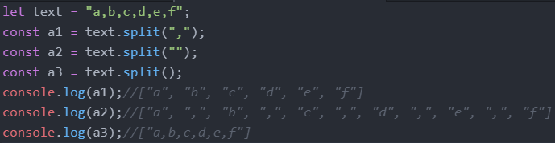

**Sets**

**Random**

Math.random() returns a random number between 0 (inclusive) and 1 (exclusive)

Ex: Return a random integer between 1 and 10: Math.floor((Math.random() * 10) + 1);

**Immutable Vs Mutable Data Types**

Immutable: Numbers, Strings, Null, Undefined, Booleans

In the example below, when we do let b = a, b takes on the value of a, not the memory address of a. As well the 10 which is the value of a and the 10 which is the value of b are two different 10s as they are stored in different memory addresses.

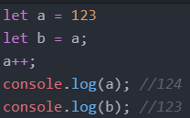

Mutable: Arrays, Objects, Functions, Classes, Maps, Sets

In the example below, when we do let b = a, b takes on the memory address of a.

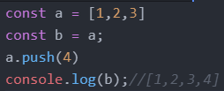

**If Statements**

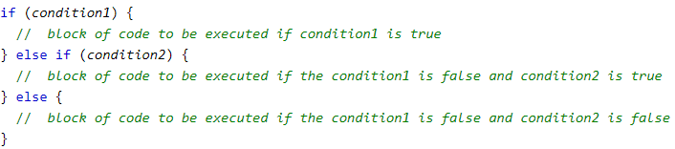

Logical Operators in Javascript such as && or || evaluate from left to right and they short circuit. Short circuiting means that in JavaScript when we are evaluating an AND expression (&&), if the first operand is false, JavaScript will short-circuit and not even look at the second operand. The same applies for OR if the first operand is true. Through short circuiting, the following two blocks of code are the same.

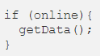 

In the left block of code, if online is true, getData is run. If online is false, getData isn’t even looked at. In the right block of code, it reads from left to right so it first checks if online is true. If online is false, it short circuits and doesn’t even read the getData(). If online is true, it runs getData(). Note that getData() is any function and doesn’t have to return a boolean.

Thus, code such as isLoaded && renderContent() is very common in react when it comes to rendering content conditionally without having to use an if statement.

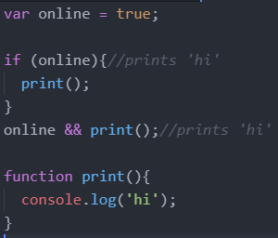

**Ternary Operator**

The syntax for a ternary operator is condition ? expr_if_cond_is_true : expr_if_cond_is_false

This ternary operator should only be used for basic if statements, don’t overdo it.

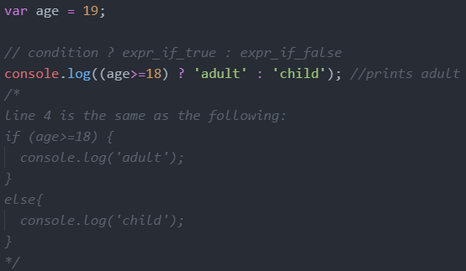

Multiple Operations Per Condition

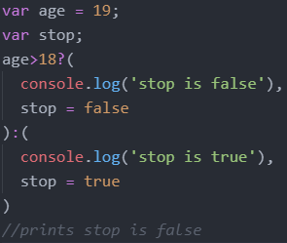

Nested Ternary Operations

Don’t use nested ternary operators, it just makes it more difficult to read

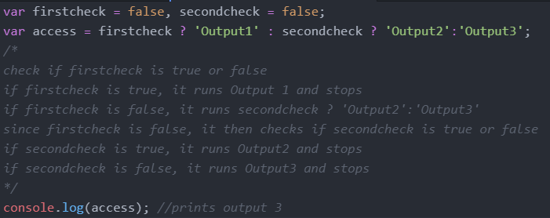

The following two conditions (one with if, one with ternary) are equivalent

**Loops**

For Loops

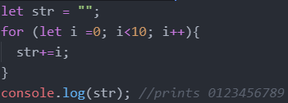

While Loops

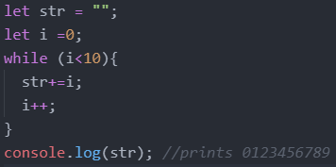

Break and Continue

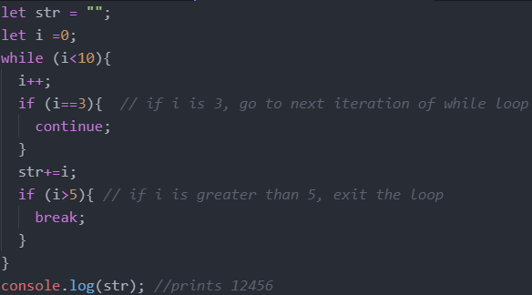

**Function**

Declaration

The function declaration (function statement) defines a function with the specified parameters.

Function declarations in JavaScript are hoisted to the top of the enclosing function or global scope. You can use the function before you declared it

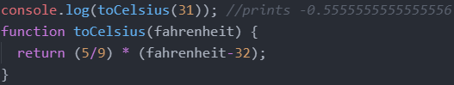

Functions are pass by value, Function arguments are local variables in JavaScript.

Reference values are also passed by values. The value passed in is the memory address.

Consider the code below:

The console will output the person object with an age of 26. But if the parameter is pass by value, how is it able to change the person object?

First, define the person variable that references an object with two properties name and age.

Next, define the increaseAge() function that accepts an object obj and increases the age property of the obj argument by one.

Then, pass the person object to the increaseAge() function:

Internally, the JavaScript engine creates the obj variable that points to the same memory address as the object. After that, increase the age property of the obj variable by one inside the increaseAge(). But since obj and person point to the same memory address, changing obj also changes person.

It seems that JavaScript passes an object by reference because the change to the object is reflected outside the function. However, this is not the case. In fact, when passing an object to a function, you are passing the memory address of that object, not the actual object. Therefore, the function can modify the properties of the object via its memory address.

However, you cannot change the memory address of the object that is passed as a parameter.

The code is the same as above. The obj variable points to the same location in memory as the person object. But the second we say obj = { name: ‘Jane’, age: 22 }, the obj variable points to a new location in memory, thus not changing any properties of the person object.

Expression/Anonymous

A function expression can be stored in a variable

Definition

The function keyword can be used to define a function inside an expression.

Hoisting

Function expressions in JavaScript are not hoisted, unlike function declarations. You can't use function expressions before you create them.

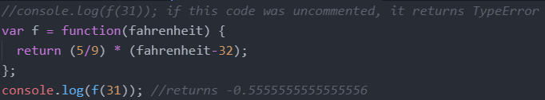

Named Function Expression

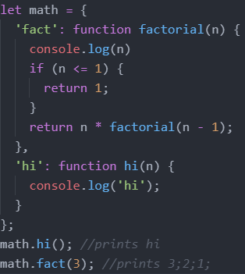

Arrow Functions

Arrow functions allow us to write shorter function syntax

Below shows how the code gets shorter and shorter and closer and closer to arrow function notation using the functions hi1, hi2, hi3, hi4.

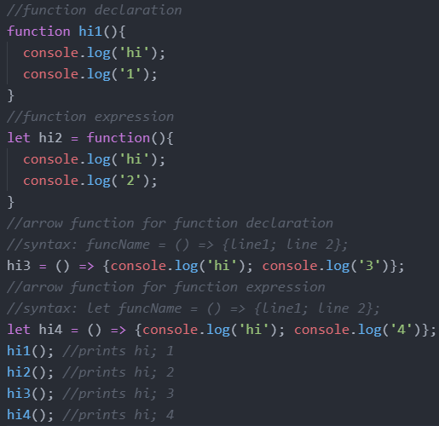

The following functions are the same, aside from their name

Arrow functions don’t really decrease the amount of code you have to write, but it can be very useful when you need to create an anonymous function that doesn’t have any descriptive function name.

In the example above, the second eventlistener uses an arrow function while the first doesn’t.

However, there is one more difference between arrow functions and normal functions

When we do person.printNameArrow() on line 20, it prints “Arrow: Bob”

When we do person.printNameFunction() on line 21, it prints “Function: ”.

The “this keyword” is different inside a normal function and an arrow function. Normal functions define the “this keyword” depending on where the function was called. Since the printNameFunction was called on line 21, this.name for the printNameFunction would have the same scope as where the printNameFunction was called. In this case, this.name for the printNameFunction has global scope. But this.name has not been defined in the global scope which is why nothing is being printed. Notice if we did console.log(this.name), it would print nothing because this.name is not defined in the global scope.

On the other hand, the “this keyword” has the same scope as inside the printNameArrow function. The this.name for the printNameArrow does not redefined when we use an arrow function. Thus, this.name for the printNameArrow does not have global scope, but rather the same scope as inside the printNameArrow function and this.name has been defined in the printNameArrow function scope (in line 3) which is why it prints “Bob”.

Because of this, we generally use arrow functions since the effect that normal functions have on the “this” keyword is really confusing.

Recursion

* Text

  Description automatically generated will print A screenshot of a phone

  Description automatically generated with low confidence

**Template Literals**

Template Literals use back-ticks (``) rather than the quotes ("") to define a string.

With template literals, you can use both single and double quotes inside a string, multiline strings, and interpolate variables and expressions into strings. In order to add a variable inside a template literal the variable must be wrapped inside curly braces that start with a dollar sign ${}.

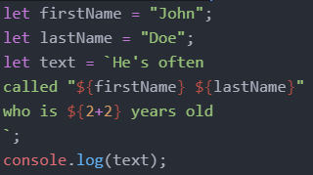

Template literals also give you the ability to define a string on multiple lines and keep all of the whitespace when printed.

One thing to watch out for with this approach, though, is that even the extra whitespace used at the beginning of lines is included in the output. This can lead to some confusing bugs with the output if you are not careful.

Tagged Template Literals

* Tagged template literals are simply the ability to run a function on the content of a template literal.
* An example of an already existing tagged template literal is the String.raw function. This tagged template literal will make it so that all escape sequences such as new lines are not computed and instead just printed as plain text.
* Text

  Description automatically generated
* Immediately, looking at this code looks weird. There are no parenthesis around the argument to String.raw, but that is how tagged template literals work. A tagged template literal is called by putting the name of the function and then immediately following it with a template literal string.
* We can also pass in our own functions to be applied on a template literal.
* Text

  Description automatically generated
* The first parameter to the function is an array of all the strings in the template literal separated by the ${} expressions.
* Text

  Description automatically generated
* The rest of the parameters to the function correspond with each of the ${} expressions in the order they appear in the template. This means if there are four ${} expressions in the string then there will be four extra variables passed to the function, one for each variable.
* Text

  Description automatically generated
* Many times you will not know how many ${} expressions a string will have, so you can use the rest operator to group all the ${} expressions into one array.
* Text

  Description automatically generated
* With this syntax we now have all the information we need to reconstruct the string passed into the tagged template literal.
* Text

  Description automatically generated
* Recall strings is an array of all the all the strings in the template literal separated by the ${} expressions. (does not include the stuff inside the ${} expressions)
* Recall …values is a array of the stuff inside ${} expressions.
* Recall that reduce’s first parameter is the function that will be applied to all the elements of a given array. The second parameter is the initial value. The function (first parameter of reduce) says that it will add the next thing inside the ${} expressions followed by the next string seperated by the ${} expressions all onto the end of the previous result.
* The output is as follows:
* My name is
* My name is Kyle and I love
* My name is Kyle and I love weight lifting.
* One thing we could do is bold all values from ${} expressions since we have access to each value inside the values array.
* Text

  Description automatically generated
* Removing Newlines From Multiline Strings
* Text

  Description automatically generated

**Error Handling**

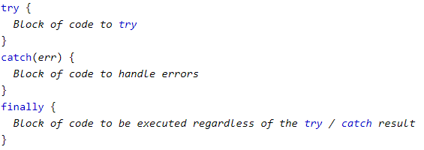

Ex:

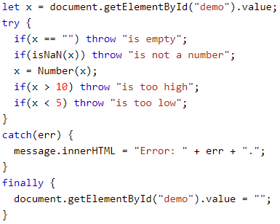

**DOM (Document Object Model)**

* The Document Object Model (DOM) is an application programming interface (API) for manipulating HTML documents.
* The DOM represents an HTML document as a tree of nodes. The DOM provides functions that allow you to add, remove, and modify parts of the document effectively.
* The DOM is not part of the JavaScript language, but is instead a Web API used to build websites.
* The DOM represents an HTML document as a hierarchy of nodes.
* Consider the following HTML document:
* Text

  Description automatically generated with medium confidence
* The following tree represents the above HTML document:
* Diagram

  Description automatically generated
* An example of another tree could be the following:
* Diagram

  Description automatically generated
* In this DOM tree, the document is the root node. The root node has one child node which is the <html> element.
* The <html> element is called the document element. Each document can have only one document element. In an HTML document, the document element is the <html> element.

Node Types

* Each node in the DOM tree is identified by a node type. JavaScript uses integer numbers to determine the node types. The following table illustrates the node type constants:
* Graphical user interface

  Description automatically generated
* To get the type of a node, you use the nodeType property: 
* You can compare the nodeType property with the above constants to determine the node type. For example:
* Text

  Description automatically generated with medium confidence

The nodeName and nodeValue properties

* A node has two important properties: nodeName and nodeValue that provide specific information about the node.
* The values of these properties depend on the node type. For example, if the node type is the element node, the nodeName is always the same as the element’s tag name and nodeValue is always null.
* For this reason, it’s better to test node type before using these properties:
* Text

  Description automatically generated

Node vs Element

* A node is anything within an HTML documents including comments, text, HTML elements, and more.
* An element is specific type of node with a node type Node.ELEMENT_NODE, which is equal to 1. Elements are only HTML elements such as <span>, <div>, <body>, <a>, etc.
* Since an element is a specific type of node, all the methods/properties that apply to nodes apply to elements as well. But an element has some additional specific properties that nodes in general don’t have.
* Oftentimes, we use element instead of nodes because we don’t really care about comments or text.
* The following picture illustrates the relationship between the Node and Element types:
* Diagram

  Description automatically generated
* Consider the HTML below:
* Text

  Description automatically generated
* If we did the following, parent1 would be the div with the class name of “parent-1”. Parent1.parentElement gets the parent element of parent1 which is the div with the class name of “grandparents”.
* Graphical user interface, text

  Description automatically generated
* However, if did the following, we would get the exact same thing.
* 
* They are the same since the div with class name of “grandparent” is both an element and a node.
* However, lets consider the following code. We would log out an empty HTML collection.
* 
* If we used childNodes instead as shown below, we would get the following:
* 
* A picture containing text

  Description automatically generated
* Notice we don’t log out an empty HTML collection but a NodeList that contains some text. This is because childNodes returns all the nodes of a given element. Text is a node, but not an element which is why childNodes contains the text but children doesn’t.
* All HTML methods has two versions, one for getting the elements and one for getting the nodes.

HTML Collection vs NodeList

* An NodeList contains nodes while an HTML collection only contains elements.
* Only the forEach array method can be used on NodeList. However, no array methods can be used on HTML collections.
* Live Updates
  + A live update is when a new element is added to the page and it would match the elements in the list, it is automatically added to the list.
  + An html collection always live updates
  + A node list sometimes live updates
  + Consider the code below:
  + Text

    Description automatically generated
  + The below code is essentially adding a new parent div to the grandparent div. Let’ say we use getElementsByClassName which returns an HTML collections.
  + Graphical user interface, text

    Description automatically generated
  + The output would be the following:
  + Graphical user interface, text, application

    Description automatically generated with medium confidence
  + Notice that the outputs are different as the new parent div we added to parents was displayed. This is because we said parents = document.getElementsByClassName which returns an HTML collection which automatically live updates itself.
  + Now consider the code below where we use querySelectorAll instead of getElementsByClassName.
  + Text

    Description automatically generated
  + The output would be the following:
  + Graphical user interface, text, application

    Description automatically generated
  + Notice that the outputs are the same even though we created a new parent div and added it to parents. This is because we used querySelectorAll which returns a NodeList which does not have live update.

Node Relationships

* Any node has relationships to other nodes in the DOM tree. The relationships are the same as the ones described in a traditional family tree.
* For example, <body> is a child node of the <html> node, and <html> is the parent of the <body> node.
* The <body> node is the sibling of the <head> node because they share the same immediate parent, which is the <html> element.
* The following picture illustrates the relationships between nodes:
* Diagram, schematic

  Description automatically generated

DOM Traversal

|  |
| --- |
| **Finding HTML Elements** |
| **Method** |
| document.getElementById(“id_name”) (return is Element type) |
| document.getElementsByTagName(“p”) (return is NodeList) |
| document.getElementsByClassName(“class_name”) |
| document.querySelector(“.className”) (This only gives us one element despite many elements possibly having the class name of className. This returns the first element with the class name of className) (returtn is Element Type) |
| document.querySelectorAll(“.className”) (this gives us all of the elements with the class name of className). (return is NodeList) |
| document.querySelector(“#idName”) |

Consider the HTML below:

Selecting Children

Suppose we are given a DOM element and we want to get all the elements right underneath it. (not to the side of it or above, but right below), we can use .children.



The .children will give us all the children of a given element. In this case, the children would be the two divs with class of parent. The datatype of parents is an HTMLCollection which is a live, ordered collection of the DOM elements which are children of grandparent. You can access the individual child nodes in the collection by using either the item() method on the collection, or by using JavaScript array-style notation. If the element has no element children, then children is an empty list with a length of 0.

To make it easier for us to use the collection of children elements, we couldve said the following instead which makes it an array



Thus, parents[0] would give us the Element object that represents the first element in parents.

Selecting Descendants

Suppose we are given a DOM element and we want to find a certain element below it (not to the side of it or above it, but below), we can use .querySelector



Notice we are apply the querySelectorAll on a single element object. This is no different that what we were doing before since before, we applied querySelector on document which is the root node. Grandparent is now just some other node so we can also apply querySelector on it no differently.

In the above example, we are looking for the all the elements that have a class of “child” that are also descendants of the Element object stored in the grandparent variable.

Selecting Parents

Suppose we are given a DOM element and we want to find the element right above it (not to the side of it or below it, but right above), we can use .parentElement. We could also use .parentNode but that might sometimes select a node which is not what we want.

Selecting Ancestors

Suppose we are given a DOM element and we want to find a certain element above it (not to the side of it or below it, but above), we can use .closest which works the same as querySelector but closest goes upwards while querySelector goes down the tree.



When we do childOne.closest(“.grandparent”), we will go to childOne’s parent to get an element with class “parent”. Since “parent” is not “grandparent”, we go look at “parent”’s parent which does have a class of “grandparent”.

Selecting Siblings

Suppose we are given a DOM element and we want to find the element right after it with the same hierarchy. We can use .nextElementSibling. We can use previousElementSibling to get the previous element with the same hierarchy.





childTwo is highlighted below in black.



 this returns the element highlighted in red.



DOM Manipulation

* HTML DOM properties are values (of HTML Elements) that you can set or change.
* HTML DOM methods are actions you can perform (on HTML Elements)
* When we target an element using one of the selectors below, we get an Element object that represents the element.

Adding Elements

* + We can use append which allows us to append nodes.
  + 
  + Text

    Description automatically generated with low confidence
  + We can also append many nodes
  + 
  + We can use appendChild which only allows us to append elements. We can also appendChild 1 element at a time.
  + A screenshot of a computer

    Description automatically generated with low confidence

Creating Elements

* + We can use createElement as shown below.
  + 
  + Note that creating the element does not add the element so we also have to add it as shown below.
  + Graphical user interface, text

    Description automatically generated

Modifying Text in between Element Tags

* + We can user innerText or textContent
  + innerText
    - Graphical user interface, text

      Description automatically generated
    - Output:
    - Graphical user interface, application

      Description automatically generated
  + textContent
    - Text

      Description automatically generated
    - Output:
    - Graphical user interface, text, application, email

      Description automatically generated
  + When it comes to setting the text inside HTML elements, innerText and textContent are the same. However, when we view them, they are different.
  + Consider the HTML below:
  + Text

    Description automatically generated with medium confidence
  + Then consider the following JS Code:
  + Graphical user interface, text

    Description automatically generated
  + The output is the following:
  + Graphical user interface, application, Word

    Description automatically generated
  + Notice that textContent includes spacing while innerText doesn’t. Also notice that textContent displays ‘Bye’ but innerText doesn’t since innerText only prints out the visible text.

Modifying Elements in between Element Tags

* + We use innerHTML
  + Text

    Description automatically generated
  + Output:
  + Graphical user interface, application

    Description automatically generated
  + Notice the <strong> element we added did not output as text, but rather was turned into an HTML element which is why the text “Hello World 2” is bolded.
  + However, if we are getting the text for the innerHTML from the user, it is possible the user inputs some malicious stuff so innerHTML is not that secure.
  + What is more secure is the following using innerText which does the same as the above, but in a more secure way:
  + Text

    Description automatically generated

Removing Elements

* + Graphical user interface, text

    Description automatically generated
  + Notice we remove an element by using .remove() which completely removes it from the HTML. But we can still access it in the JS as shown in the following line where spanBye is added back.

Getting Element Attributes

* + We can get attributes such as id’s and title’s of an element using getAttribute as shown below
  + Text

    Description automatically generated
  + However, attributes are oftentimes already methods of an element so we can just do the following instead:
  + Graphical user interface, text

    Description automatically generated

Setting Element Attributes

* + Below we change the id to sdfsdfsd
  + Text

    Description automatically generated
  + Or we can also do the following
  + 

Removing Element Attributes

* + By using removeAttribute as shown below, we remove the id attribute of spanHi so spanHi no longer has an id at all.
  + Text

    Description automatically generated

Modifying Element Classes

* + We can use classList to allows us to use many methods is manipulating the class of an element.
  + Adding a class to an element
    - 
  + Removing a class from an element:
    - 
  + Toggle a class from an element
    - (removes the class if the element already has it, or adds the class if to the element if the element doesn’t have it).
    - 
    - We could also pass in a boolean parameter which adds it if we say true and removes it if we say false
    - 

Modifying CSS

* + We can use style to allows us to use many methods is manipulating the style of an element.
  + 
  + 
  + Notice above we have to convert background-color which is what we would write in CSS to backgroundColor using camelCase.

|  |
| --- |
| **Adding Events Handlers** |
| **Method** |
| document.getElementById(id).onclick = function(){code}  Examples:  document.getElementById("myBtn").onclick = displayDate; |

Events

onclick

onmousedown

onmouseup

onload

onunload

onchange

onmouseover

onmouseout

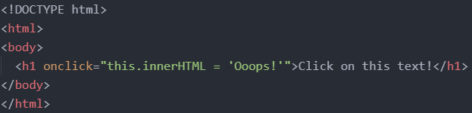

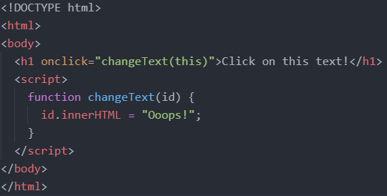

Event Listener

Syntax: element.addEventListener(event, function, useCapture);

- The first parameter is the type of the event (like "click" or "mousedown" or any other HTML DOM Event.). Note that you don't use the "on" prefix for the event; use "click" instead of "onclick".

- The second parameter is the function we want to call when the event occurs.

- The third parameter is a boolean value specifying whether to use event bubbling or event capturing. This parameter is optional.

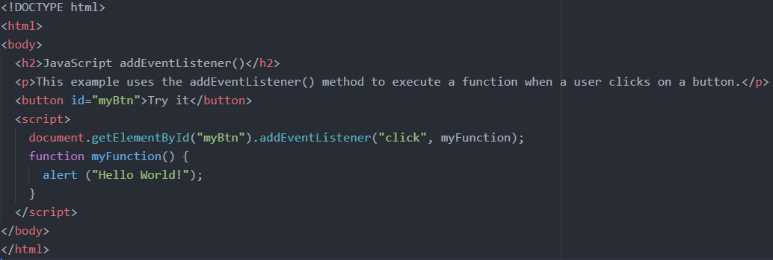

Forms

Get the value of an input field through document.getElementById("input_field_id").value;

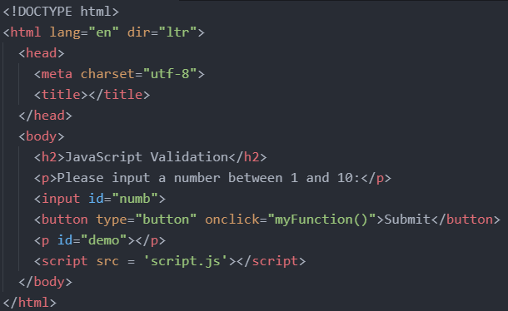

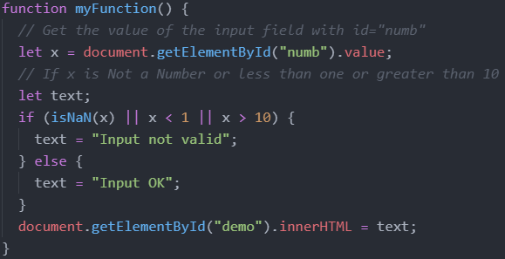

**Classes**

A JavaScript class is not an object. It is a template for JavaScript objects. An object is an specific instantiated version of a class with all the property values filled in.

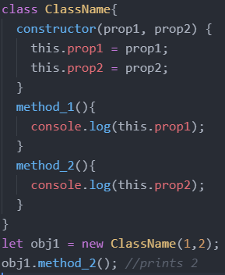

It has to have the exact name "constructor". The constructor method is called automatically when a new object is created. If you do not define a constructor method, JavaScript will add an empty constructor method.

Inheritance

To create a class inheritance, use the extends keyword.

A class created with a class inherits and inherits all the methods from another class.

The super() method refers to the parent class. By calling the super() method in the constructor method, we call the parent's constructor method and gets access to the parent's properties and methods.

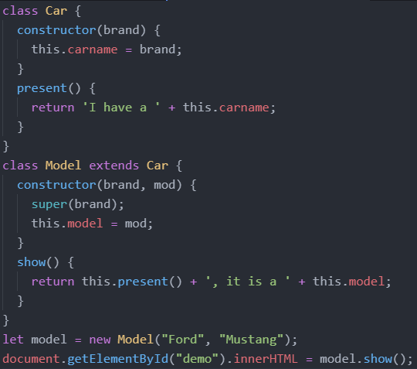

Getters and Setters

To add getters and setters in the class, use the get and set keywords.

The name of the getter/setter method cannot be the same as the name of the property, in this case carname.

Many programmers use an underscore character _ before the property name to separate the getter/setter from the actual property. Notice that setters and getter methods can have the same name.

To use a getter or setter, use the same syntax as when you set a property value, without parentheses.

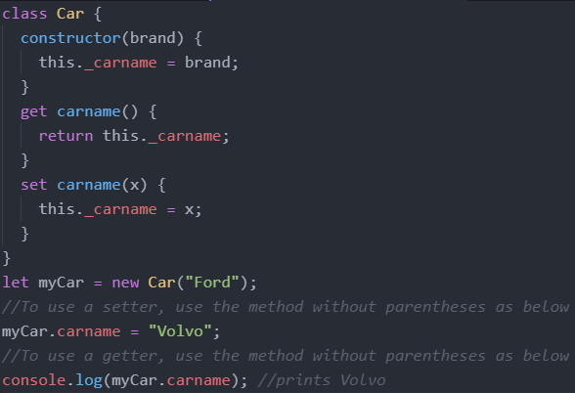

Hoisting

Cass declarations are not hoisted so you must declare a class before you can use it.

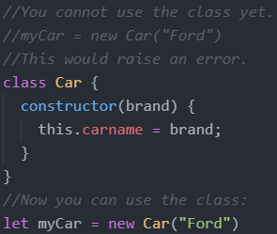

Static Class Properties and Methods

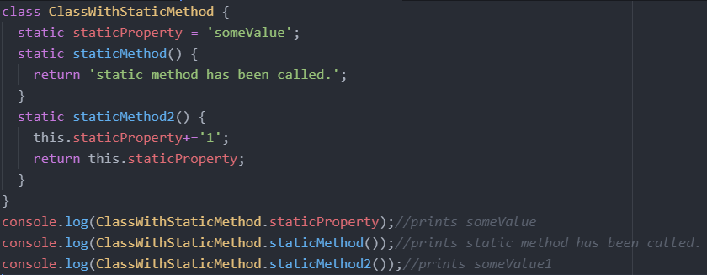

**Modules**

Modules can only be used in live servers, by directly clicking the file on our desktop.

Assume we have the following directory structure where main.js imports code from util.js.

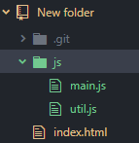

In the html, make sure to link to the main js file with type = 'module'.

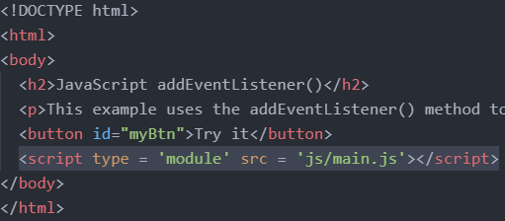

Single Export

In the utils.js file, we have the following. We have a const and function declaration as normal, but we stick the word export in front. This makes the const and function exportable.

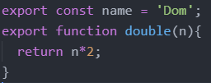

We can also do the following

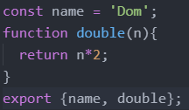

In the main.js file, we do import {item1, item2, item3, …} from 'filePath.js';

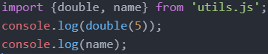

We can also change the names of imported items

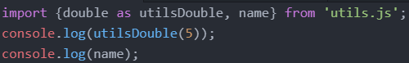

Multiple Export

We still have to put export for each thing we want to export in the utils.js file.

But in the html file, we can do * instead of listing each item we want to import.

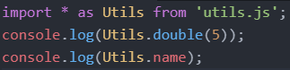

Default Export

The export default keyword means the item is the default export for the module. One module can only have 1 default export.

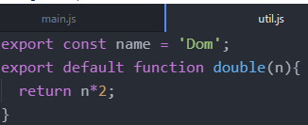

In the main.js folder, we can do the following. Notice there is no item called bottle in the utls.js module. Thus, bottle will be used for the default export which is the function.

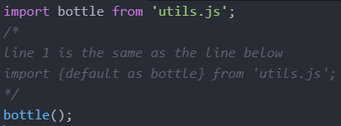

**Callbacks**

A callback is a function passed as an argument to another function.

This technique allows a function to call another function.

A callback function can run after another function has finished.

Consider the following 2 scenarios that don’t use callbacks that allow us to do a calculation, and then display the result.

Scenario 1: You could call a calculator function (myCalculator), save the result, and then call another function (myDisplayer) to display the result:

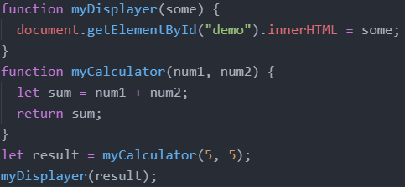

However, the problem is that you have to call two functions to display the result.

Scenario 2: You could call a calculator function (myCalculator), and let the calculator function call the display function (myDisplayer):

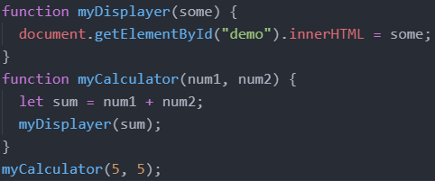

The problem is that you cannot prevent the calculator function from displaying the result.

Now, we will use callbacks.

You could call the calculator function (myCalculator) with a callback, and let the calculator function run the callback after the calculation is finished.

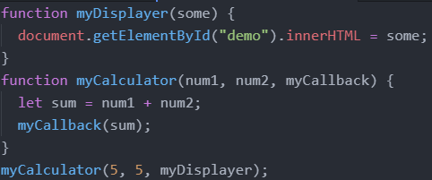

In the example above, myDisplayer is the name of a function and is passed to myCalculator() as an argument.

When you pass a function as an argument, remember not to use parenthesis.

Right: myCalculator(5, 5, myDisplayer);

Wrong: myCalculator(5, 5, myDisplayer());

Where callbacks really shine are in asynchronous functions, where one function has to wait for another function (like waiting for a file to load).

**Asynchronous Functions**

Functions running in parallel with other functions are called asynchronous.

setTimeout()

A good example is JavaScript setTimeout() to specify a callback function to be executed on time-out.

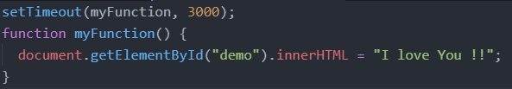

In the example above, myFunction is used as a callback.

The function (the function name) is passed to setTimeout() as an argument.

3000 is the number of milliseconds before time-out, so myFunction() will be called after 3 seconds.

When you pass a function as an argument, remember not to use parenthesis.

setInterval()

you can specify a callback function to be executed every few seconds(the interval time)

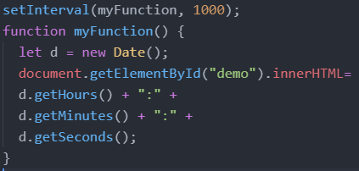

In the example above, myFunction is used as a callback.

The function (the function name) is passed to setInterval() as an argument.

1000 is the number of milliseconds between intervals, so myFunction() will be called every second.

Waiting for Files

If you create a function to load an external resource (like a script or a file), you cannot use the content before it is fully loaded.

This is the perfect time to use a callback.

This example loads a HTML file (mycar.html), and displays the HTML file in a web page, after the file is fully loaded:

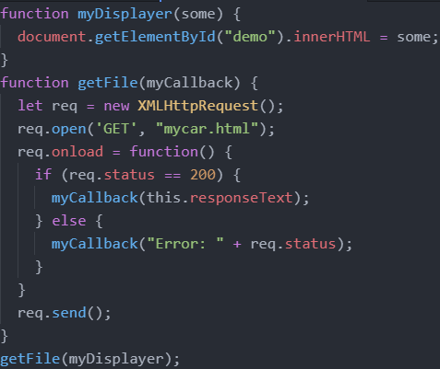

In the example above, myDisplayer is used as a callback.

The function (the function name) is passed to getFile() as an argument.

**Promise**

A promise in JS is like a promise in real life. You commit to something by promising to do something and you either fulfill your promise (resolve) or fail to keep your promise (reject)

In the code below, in the promise we call a function that does something(which can succeed or fail). In that function, we will also either call the resolve function if the task was successful and the reject function if the task failed. The .then method does what should happen if the resolve function was called and the .catch method does what should happen if the reject function is called.

Promises are really good when you need to do something that takes a long time(and might fail) in the background. For example, if we have to download an image from a different server.

Promises are meant to replace callbacks

The following two functions are the same. The one on the left uses callbacks. The one on the right uses promises.

For the left code, if the task is unsuccessful(there is an error), the function will execute the errorCallback function and if the task is successful, then the function will execute the callback method.

For the right code, if the task is unsuccessful(task failed), the reject function will be executed. Otherwise, the task is successful, and the resolve function will be executed.

**Async Await**

* Different syntax that can replace promises and make it look cleaner

